6 Midnimo Cross Cultural Community School
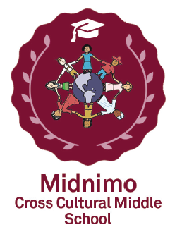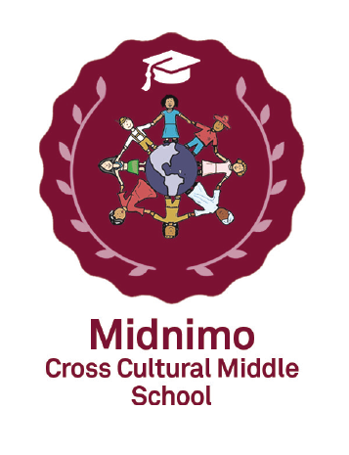
1567 Loretta Ave
Columbus, OH 43211
(IRN 000780)

ANNUAL REPORT
2021-2022

Midnimo Cross Cultural Community School (Midnimo) received 5 “stars” (“A” equivalent) in BOTH the “Progress” and “Gap closing” metrics on the 2022 State of Ohio Report Card! In addition, Midnimo had an outstanding 6-point rise in its Performance Index for overall academic performance! Midnimo continues to create an academic-rich, safe and respectful multicultural environment that facilitates accelerated academic achievement while instilling a desire to learn, taking appropriate risks, and to accept challenges. Our school community is committed in supporting our students in their pursuit of Real-World learning activities and nurturing high self-esteem and respect for others. We believe that everyone can succeed in becoming accomplished thinkers and independent learners. To accomplish this mission, our curriculum is aligned to and paced with Ohio’s New Learning Standards. Secondly, we consistently monitor student progress and adjust our instructional strategies based on benchmark and interim assessments. In addition, our 100% highly qualified teachers work collaboratively so that there is an integration of academic content across the curricula, as well as the most current use of technology to enhance instruction. Specific initiatives are implemented to focus on our significant English Learner student population (41%).
BAR GRAPHS SHOWING THE STUDENT PERFORMANCE AT MIDNIMO SCHOOL:
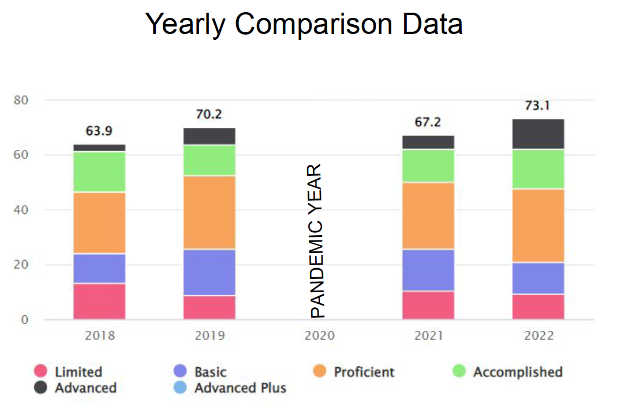
Outstanding growth in all content areas at Midnimo School- data from the ODE-Value Added (EVAAS database).
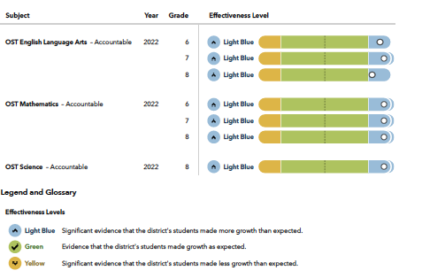
Midnimo Cross Cultural Community School CONTINUES to provide excellent education, a positive learning environment, with a view towards preparing students for meaningful careers.

Mission: To make a “World of Difference” in the lives of our students by utilizing evidence-based education practice within an environment high in morals, social standards and care; measured by academic growth metrics.

Vision: To prepare students academically, socially and morally to become effective contributors to society with a focus on Real World Learning and career exploration.
Demographic Data
Enrollment

During the 2021-2022 school years, Midnimo Cross-Cultural Community School had a total of 141 students.

Students enrolled in grades 6-8 as follows:

Grade 6th 56

Grade 7th 48

Grade 8th 37

Student Composition
Black 74 %
White 0 %
Multiracial 0 %
Hispanic 26 %
Economically Disadvantaged 100 %
Students with Disabilities 7 %
EDUCATIONAL PHILOSOPHY

Midnimo is committing to the following:

- Providing a safe, caring and disciplined learning environment.
• Accepting no excuses for any child's failure to learn.
• Expecting and teaching all students to exhibit exemplary behavior.
• Emphasizing academic basics, especially in primary grades.
- Emphasizing only high student achievement based on rigorous, meaningful standards measured frequently (daily).
• Utilizing evidence-based curricula and instructional techniques.
- Employing a mastery model of learning in all academic areas to promote skill generalization.
• Treating parents as customers.
• Freeing teachers from inefficiencies and equipping/coaching them to teach all students to high levels of academic success.
- Utilizing the latest advances in technology.

The educational philosophy of the program states that every child can learn if taught appropriately. In other words, children who fail have been failed by the instruction to which they have been submitted. Equipped with a proven curriculum, school staff must follow successful instructional practices, evaluate each child each day, and as needed, alter ineffective teaching practices to meet the needs of every child. The school will emphasize basic skill development and mastery at every stage so as to make it most probable that skills will be applicable and generalizable beyond the immediate instructional setting.
Midnimo Financial Plan:
Midnimo Financial Plan:
Total Operating Revenues $1,391,856
Total Operating Expenditures $1,622.776
Non Operating Revenues $598,883
Beginning Cash $90,319
Ending Cash $458,282

- Academic Assessment and Accountability: Students are administered norm-referenced NWEA assessments three time a year to assess academic growth. We are proud to report that strong sustained consistent growth was again evident in math, ELA and science (Figure below). This is corroborated by the school meeting or exceeding one year of academic gains on Value-Added (or Progress) metrics for each of the last 14 years!
= Expected academic gains for the respective grade cohort-Fall 2021 to Spring 2022 MAP testing 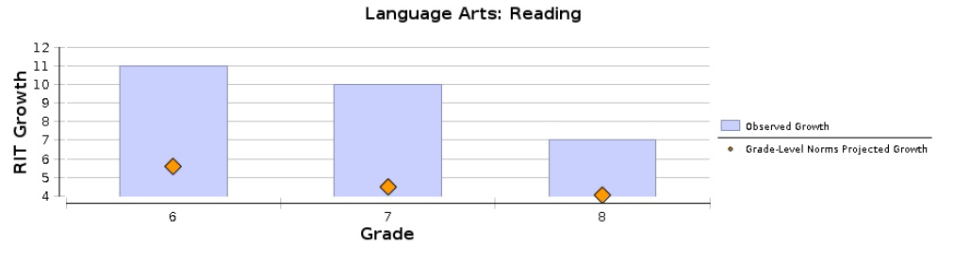
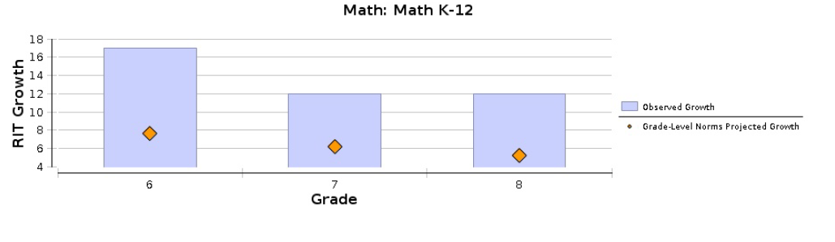
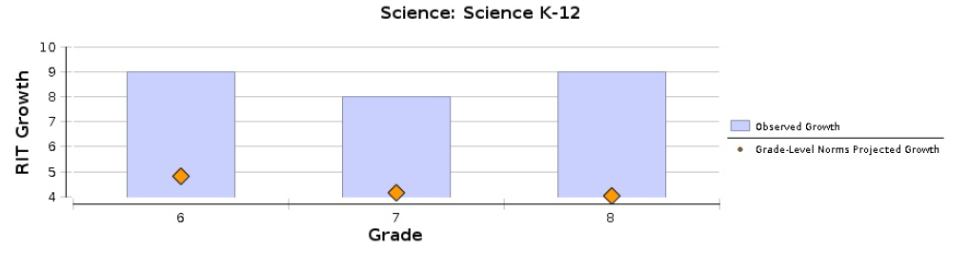

2021-2022 Ohio State Assessments:
Grade | Subject | Percent proficient
6 | Reading | 47
 | Math | 53
7 | Reading | 62
 | Math | 50
8 | Reading | 42
 | Math | 42
 | Science | 47

Governance: – The Five member Governing Board of Midnimo Cross Cultural Community School:
- Gloria Anderson
- Louis Morgan
- Paula Parlett
- Dr. Kenny Roman
- Shonen Thomas

Program Location:
1567 Loretta Ave,
Columbus, OH 43211

